CybE / CprE 2310: Cyber Security
Concepts and Tools

Lab-12 Report
Student Name: Jack Goeders

You must copy the template provided and fill in the tables accordingly. Your lab report is REQUIRED to use the template below, or points will be taken away. You are expected to be very thorough in your answers. Vague descriptions or responses that don’t correctly answer the questions from the table will receive zero credit. As a general rule, the more descriptive and informative your answer, the more likely you will receive credit. The less descriptive and uninformative your answer, the more likely it is that you will receive no credit. A good answer should be no fewer than two sentences.

An example of non-acceptable work:
Machines | How did you gain access? | What specific harm could be done? | How can you remediate it?
Machine X | I got access with RDP. | Because I could log in to the machine, I could do whatever I wanted with the user permissions. | Close the port

An example of acceptable work:
Machines | How did you gain access? | What specific harm could be done? | How can you remediate it?
Machine X | After running a port scan on machine X, I was able to find that Y service is open and running on port Z. After connecting to the port from my Kali box, I was able to gain RDP access without a password and login into machine X as user W. The command I used to perform this is [insert command]. | Because I logged in as user W, I had access to the user’s files, shared workspace, contacts, calendar, and more. Because I have access to this information, I would be able to sell this information, blackmail the employee, modify or steal information, create files, send phishing emails, and various other crimes. | Because I gained access through an open port ‘Z’ from an unknown machine, there are a few options. First, I could add a firewall to isolate people from the outside world from connecting to the machine. Second, it would be smart to add a password or even MFA to log in as the user. If all else fails, if the service is unnecessary, we can close the port.
(Note: the points for each row are given on an all-or-nothing basis. You must properly fill out each column in the row to receive all of the points. Properly filling out ⅔ of the columns earns zero points. All of the fields in the row must be adequate to receive full credit for the given row.)

Exploiting three machines (8 points per row; 24 total points)
Host Machines | How did you gain access? | What specific harm could be done? | How can you remediate it?
Reception Desktop | I ran nmap 87.45.75.152 and identified that this machine was running RDP on port 3389. Since I identified this service, but had no way of getting in without login information, I put this on the backburner. However, once I gained access to Tom’s Project, I noticed that mysql was running on port 3306. So, I typed mysql and SHOW DATABASES; and noticed a database for login_info. I got all the information out of a table in it named UsernamePassword using SELECT * FROM UsernamePassword; and noticed that Rachel, an employee who works in reception, had an account with username rachel and a password of vanilla. So, I ran rdesktop 87.45.75.152, used this login information, and got in. | I currently have the ability to remote desktop to the Reception Desktop under Rachel’s account. There is a multitude of harm that can be done here. Specifically, just on the desktop alone, I can see a folder called HR Records which likely has very sensitive information about employees. I can only imagine that there is more sensitive information scattered throughout the machine. I could use this sensitive information to blackmail employees, the hospital, or patients as well as possibly frame Rachel for my actions. Also, I could install lots of different kinds of malware and attempt to move laterally throughout the hospitals machines as well. Also, after running net localgroup administrators, I can see that Rachel’s account is an administrator. This gives us full control over the system and allows us to run any command we please. This could include destruction of the system, etc. | There are a couple choices. We can block access to port 3389, and effectively disable the remote desktop service. I would personally do this, as I see no reason that the reception desktop needs to have the ability to be remotely connected to. Second, we can change passwords and have a more secure password policy in place for the reception desktop. This could involve certain complexity rules for the passwords used on the machine and the requirement to change passwords every month or so.
Clinician Desktop | I ran nmap 87.45.75.154 and identified that this machine was running SMB on port 445. Since I identified this service, I tried a nmap script to see if there were any nmap related vulnerabilities using this command: nmap –script smb-vuln* 87.45.75.154 which showed me the machine was vulnerable to Remote Code Execution in the Microsoft SMBv1 servers (ms17-10). Then, I opened up metasploit and tried to find the appropriate exploit using search ms17-010. I tried a couple of different options that popped up, but the one that ended up getting me a meterpreter was windows/smb/ms17_010_psexec. | When I dropped into a shell, I noticed that I had a shell at C:\Windows\system32 which indicates that I have administrator access to the machine. Also, after running getuid I saw that I am NT AUTHORITY\SYSTEM which means we have full control over the system. This means our commands know no limits as we are the highest-level privilege. Specifically, we can modify any system files or configurations, access any and all data (including the SAM file for hashes), establish persistence, disable any security measures, etc. Also, since this is the clinician desktop, we will likely be able to steal patient data which is in direct violation of HIPAA. We can blackmail patients and the hospital with this data. | There are a couple choices.  We can block access to  ports 445 and 139 by  putting them behind a  firewall. This will prevent  external attacks best.  However, the best solution  is to upgrade our machines  version of SMB to apply the  security patch, MS17-010,  that Microsoft has already  pushed out for it.
Tom’s Project | I ran nmap 87.45.75.175 and identified that this machine was running FTP on port 21, telnet on port 23, SMTP on port 25, finger on port 79, http on port 80, and mysql on port 3306. Since I identified the FTP service, I tried a nmap script to see if there was anonymous login allowed: nmap –script ftp-anon 87.45.75.175. This script told me that FTP anonymous login was called, so then I ran ftp 87.45.75.175 and entered “anonymous” for a username, followed by no password. From here, I had access to list all the files of the file system but could not write. So, I navigated to the /etc folder using the command cd whats_in_here/etc followed by the command get shadow – to try and read the shadow file. To my surprise, I was able to read it and noticed that the backdoor account had no password set. So, using my observation that telnet was running on port 23, I ran the command telnet 87.45.75.175 23 and entered “backdoor” followed by no password and was able to login. I then ran the id command and noticed that I was logged in as root, with access to the entire filesystem. | Now that I have achieved  remote access with the root  user, I have the highest  privilege level. Overall, I  can do anything which  means total control over  the entire system. In  specific, I can access all  data including the shadow  file (which could be good  for John the Ripper use  later for more passwords), have the ability to traverse the entire filesystem to find sensitive company/website information like passwords or patient details, establish  persistence, destroy the  system, change user  account and access  control, modify and delete  system files, etc. | Since I was able to access the machine through FTP anonymous login, a possible option is to add a firewall rule to only allow internal machines to connect via FTP. Next, it is an even better option to disable anonymous logins through FTP as anyone can login and read any file in the filesystem, including shadow, as I did. This ability to read anything should not be the default behavior either, so there must be some sort of misconfiguration that can be fixed as well.  I would not have known about the backdoor account without being able to read the shadow file. That takes me to the next remediation: this backdoor account should not exist, or it should have a password attached to it. Given the name, I imagine this account isn’t supposed to exist in the first place, so it should be deleted. Another possible solution is to not allow outside machines to connect to the machine via telnet by hiding it behind firewall rules or by disabling it altogether if remote access is not necessary (or switch to the more secure SSH).

Screenshot evidence of exploits (required to get credit for the above)
Host Machines | Screenshot(s)
Reception Desktop | 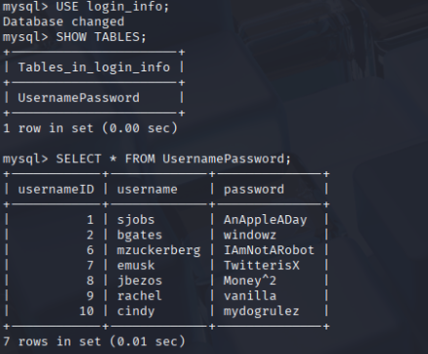  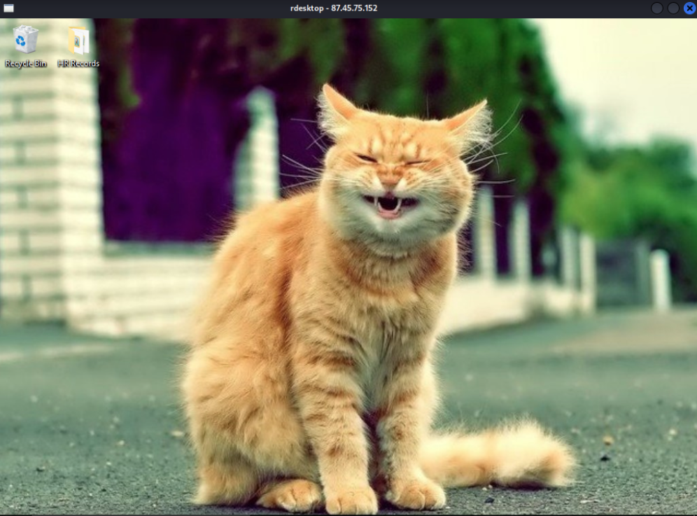
Clinician Desktop | 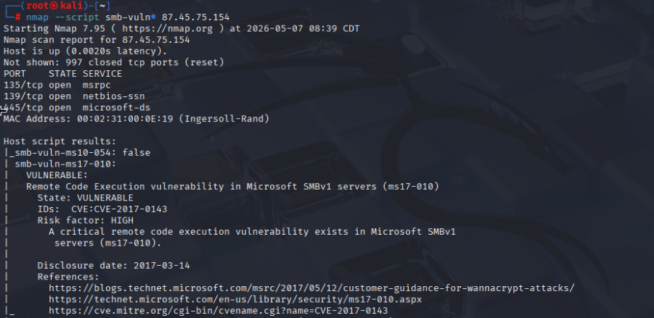  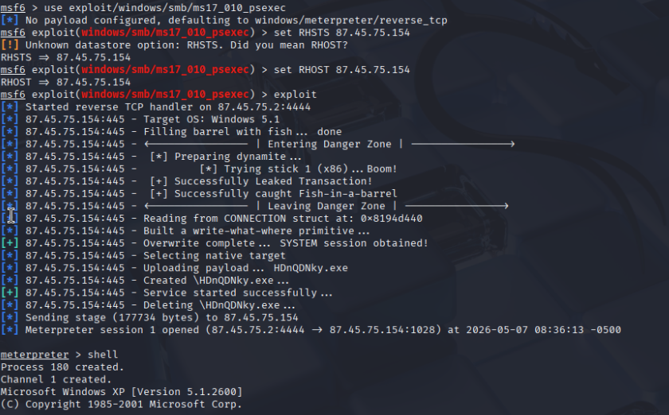
Tom’s Project | 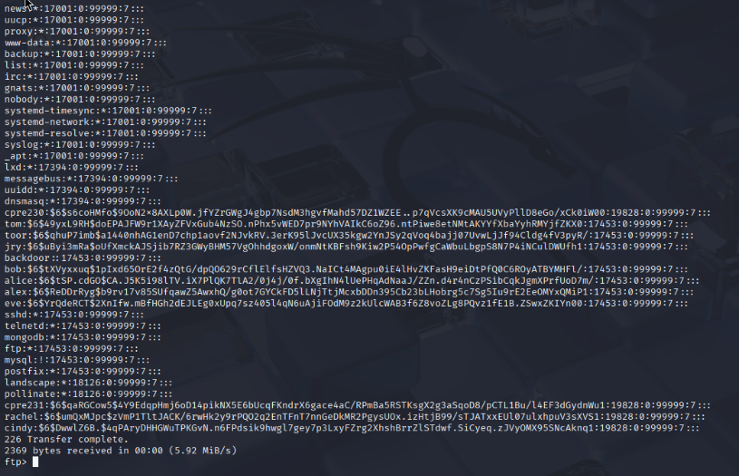  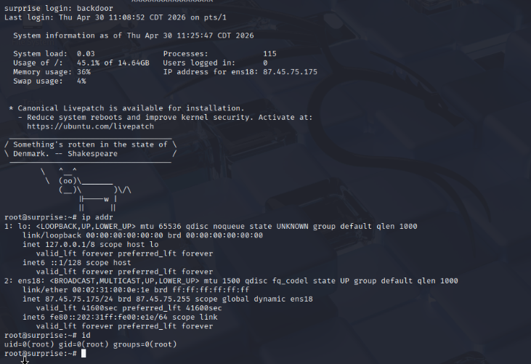

Sensitive information (8 points per row; 24 total points)
Host Machines | What information I found, and why it’s bad that I can see it.
Reception Desktop | On the desktop, there is a folder called HR Records which contains a contact for every single employee in the company. In this contact, I can see information such as name & email, home information like their address, work information like department, family information, notes, and IDs. It’s bad that I can see this as this is very personal information revealed to me through each of these contacts such as their home address and family members.  After snooping through the recycling bin, I noticed a lot of different files. After restoring all of them, I noticed there were files called IDNumbers2087 and IDNumbers2088. I looked through these and noticed that I have all the information of Caroll Shanon and John Hansen including federal taxpayer identification numbers, employer identification number, individual taxpayer identification number, adoption taxpayer identification number, social security number, and driver’s license information. It’s bad that I can see this as I have more than just personal information about these two individuals, I have enough to commit identity fraud especially with the social security number.
Clinician Desktop | After snooping through the different user folders, I noticed that, in the Cindy Rizen user folder, in her Desktop, she has a folder called Patient Data. After looking through it, I noticed that she has 16 text documents containing confidential patient data including their name, patient number, sex, smoker status, blood type, date of birth, emergency contact, allergies, and current medications. It’s bad that I can access this as this is a direct HIPAA violation. I should not be able to access the medical records of patients being seen in the hospital.  I noticed that all the other users on the Clinician Desktop also have the same Patient Data folder. I think this may be malpractice as all Clinician’s should only be able to see patient data that is their patients.
Tom’s Project | After snooping through the mysql service, I was able to find a database called login_info. After displaying all the entries in the database’s UsernamePassword table, I noticed that all the entries had plain text username and password fields that I could grab and use on the website. It’s bad that I can see this as I can now go to any web browser, navigate to the website running Tom’s Project, and gain access to it using any account listed in that table. This is also bad as passwords tend to be reused and I could use this, as I did to gain access to the Reception Desktop, to gain access to other machines throughout the network.  I was able to use the information from above to login to sjobs account on the website. From here, I was able to post as sjobs on the forum (which allows for cross-site scripting). It’s bad that I can see this as this forum is meant to be private, I now have access to possible sensitive information posted on this forum that is meant to be for employee’s eyes only.

Screenshot evidence of sensitive information (required to get credit for the above)
Host Machines | Screenshot(s)
Reception Desktop | 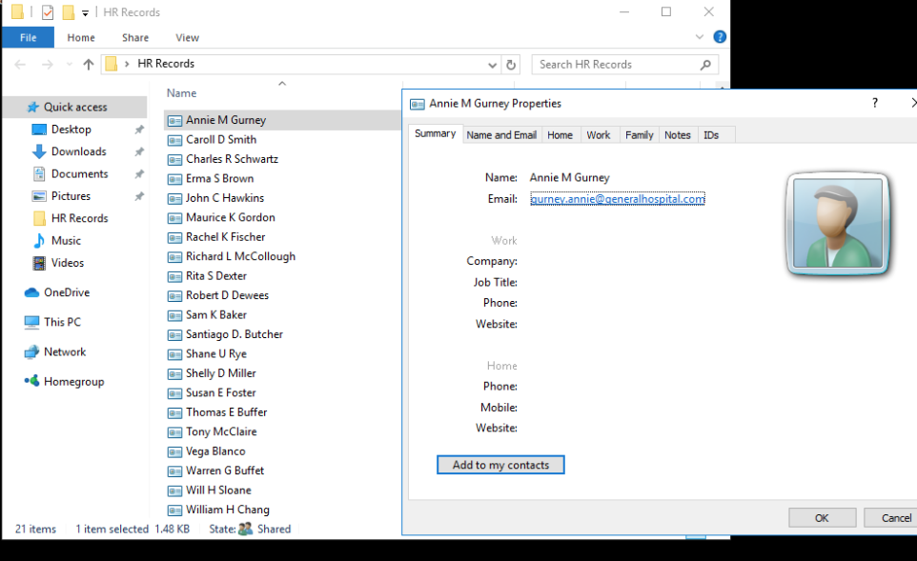  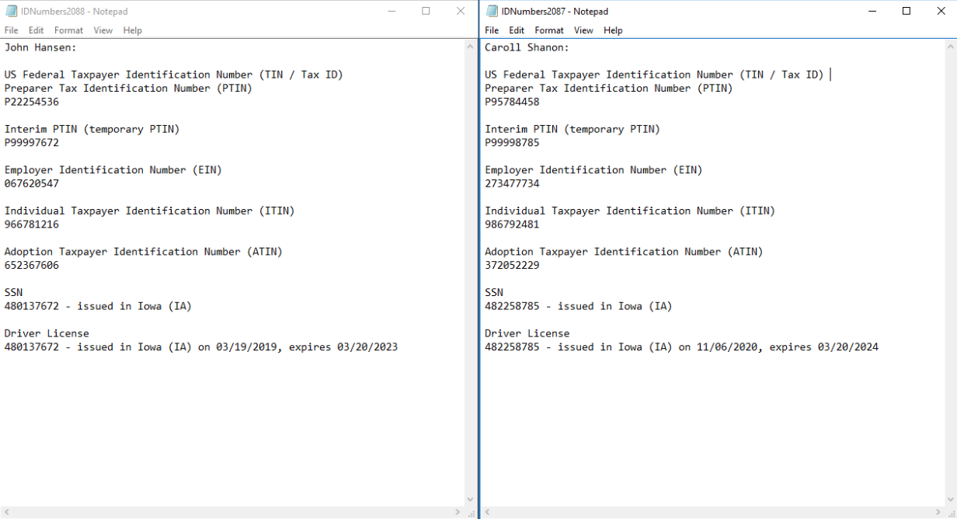
Clinician Desktop | 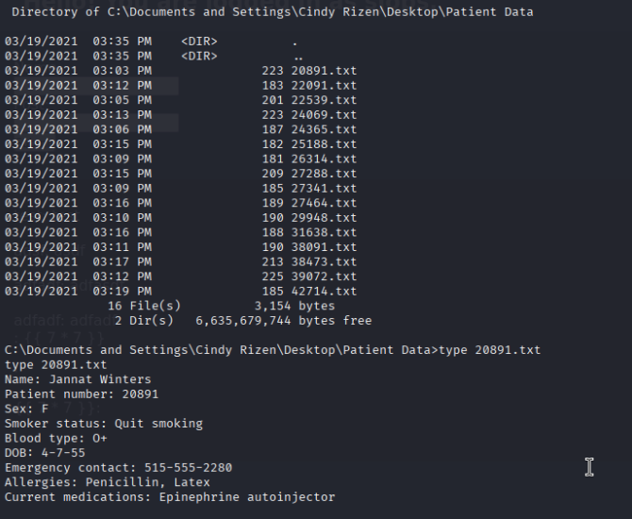
Tom’s Project | 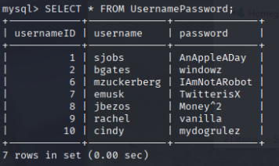  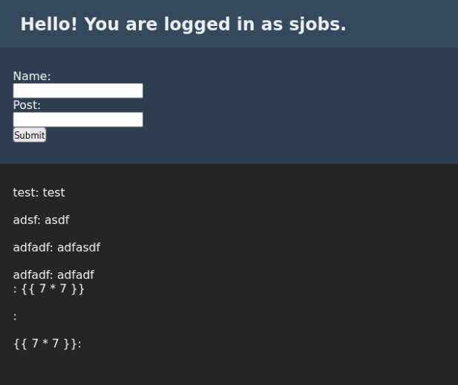

Remediation (8 points per row; 24 total points)
Host Machines | Vulnerabilities, misconfigurations, sensitive information disclosures, malpractices | Does the issue need to be fixed? Why, or why not? | If actions were taken, how did you remediate it
Reception Desktop | 1) I gained access using the RDP service and the same password and username that Rachel used on Tom’s Project’s website.  2) On the desktop, there is a folder called HR Records which contains a contact for every single employee in the company. In this contact, I can see information such as name & email, home information like their address, work information like department, family information, notes, and IDs.  3) I noticed some files in the recycling bin called IDNumbers2087 and IDNumbers2088. I looked through these and noticed that I have all the information of Caroll Shanon and John Hansen including federal taxpayer identification numbers, employer identification number, individual taxpayer identification number, adoption taxpayer identification number, social security number, and driver’s license information | 1) This issue needs to be fixed. I was able to gain access to Rachel’s account on the Reception Desktop with ease. Using Rachel’s account, I am an administrator and have access to all sorts of HR records as well as the ability to fully control the machine.  2) This issue needs to be fixed. Part of the solution is solving problem 1, the ability to gain access in the first place. However, I think that there is more that can be done here in terms of best practices that I detail in the next column.  3) This issue needs to be fixed. Part of the solution is solving problem 1, the ability to gain access in the first place. However, I think that there is more that can be done here in terms of best practices that I detail in the next column. | 1) I think the best solution is to disable RDP altogether and subsequently close port 3389. I don’t see a particular reason why the reception desktop needs to be remotely accessed. Otherwise, if it needs to be remotely accessed, we can put port 3389 behind a firewall for internal use only as it should not be accessible externally.  2) I think the best solution is to move the HR records to a secure software service that stores these records and even allows for better management of them. Then, we can block access to this software service using a firewall so that it can only be accessed internally.  3) I think the best solution is to move these very sensitive records to a secure software service that stores these records, encrypts them, and allows for the management of them. Then, we can block access to this software service using a firewall so that it can only be accessed internally. Otherwise, the best solution is to ensure that the recycling bin is emptied when deleting very sensitive files.
Clinician Desktop | 1) This machine is vulnerable to smb-vuln-ms17-010. This allows us to gain a meterpreter shell that grants root remote access to the laptop.  2) I noticed that, in the Cindy Rizen user folder, in her Desktop, she has a folder called Patient Data. After looking through it, I noticed that she has 16 text documents containing confidential patient data including their name, patient number, sex, smoker status, blood type, date of birth, emergency contact, allergies, and current medications.  3) I noticed that all the other users on the Clinician Desktop also have the same Patient Data folder. I think this may be malpractice as all Clinician’s should only be able to see patient data that is their patients. | 1) The smb-vuln-ms17-010 needs to be fixed. I was able to obtain a root shell with it, so other attackers could as well.  2) This issue needs to be fixed. Part of the solution is solving problem 1, the ability to gain access in the first place. However, I think that there is more that can be done here in terms of best practices that I detail in the next column as this is a direct HIPAA violation.  3) This issue should likely be fixed. I believe its malpractice and a HIPAA violation for other clinicians, who aren’t the patient’s caretaker, to be able to see this patient records. | 1) The best solution is to upgrade our machines version of SMB to apply the security patch, MS17-010, that Microsoft has already pushed out for it.  2) I think the best solution is to move these very sensitive records to a secure software service that stores these records, encrypts them, and allows for the management of them (something along the lines of MyChart). Then, we can block access to this software using a firewall so that it can only be accessed internally.  3) I think the best solution is to have separate patient data for each user on the machine or, as detailed in problem 2, move it to a secure software service that would handle this access control.
Tom’s Project | 1) I gained access by doing an anonymous login to FTP and navigating to the shadow file on the machine. This shadow file told me that there was an account called “backdoor” that had no password. Then, I gained access through telnet by providing this username and no password.  2) After snooping through the mysql service, I was able to find a database called login_info. After displaying all the entries in the database’s UsernamePassword table, I noticed that all the entries had plain text username and password fields that I could grab and use on the website.  3) Passwords entered on the website for certain user accounts are reused elsewhere.  4) I was able to use the information from above to login to sjobs account on the website. From here, I was able to post as sjobs on the forum (which allows for cross-site scripting). | 1) This issue needs to be fixed. I was able to read all the files on the system using ftp anonymous login. From here, I gained knowledge about an existing backdoor account, with root privileges, that had no password. I could do irreparable harm to this machine as well as possibly move laterally throughout the hospital network.  2) This issue needs to be fixed as I was able to read the password that corresponded to a given user with ease as there is zero hashing happening. From here, I was able to reuse a password used on this website to gain access to the Reception Desktop, further showing how access to one machine can mean access to many via password reuse.  3) This issue should be fixed as I had to go through no additional effort to gain access to the Reception Desktop since Rachel used the same exact username and password there.  4) The issue of being able to be logged in as sjobs will be addressed by solving problem 2. However, being able to cross-site script using the forum on the website is something that needs to be fixed as XSS can be used for many malicious actions such as stealing cookies and redirecting users to a malicious site. | 1) I think the best solution is to disable FTP anonymous login so that the entire filesystem cannot be read without a password. Then, delete the backdoor account as its clear based on the name that it is an account that is not meant to exist. Then, I would move the remote access protocol from telnet to SSH as SSH encrypts all traffic and offers a public-key authentication process that we should move to for remote access to this machine.  2) I think the best solution is to hash the passwords stored in the database. This way, even if an attacker was able to gain access, they’d gain virtually nothing by seeing the hashed passwords.  3) I think the best solution here is to have policies in place that prevent password reuse, enforce password complexity requirements, and force passwords to be changed every certain amount of time (e.g., every month).  4) I think the best solution is to treat the user input as untrusted when it comes in. We can make use of practices like auto escaping to convert special characters like “<” to “&lt;” which would prevent things like “<script>alert(1)</script>” from being passed to the forum and actually executing.

Incident Response Table (9 points per row; 27 total points)

Some potential hints of things that might be good to look for include:
- .158 (ems_laptop), do you notice any new users/files?
- .150 (www) Look for signs of users/reading data that shouldn’t be publicly shared
- .175 (toms surprise)

Be specific in what you find, being vague will get you 0 points.

Host IP | - What was accessed?  - How was it accessed?  - What was the impact of the incident?  - How did you respond to the incident?  - Screenshot of what was accessed

